CODE OF CONDUCT

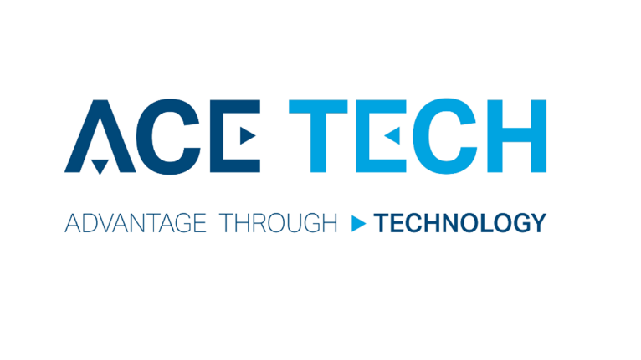

July 2019

ACE-TECH Code of Conduct
ACE-TECH adopts this code as a set of elementary values and attitudes which the company practices in the performance of its business activities. The code addresses conduct which is a reflection of the business ethics ACE-TECH subscribes to.
Compliance with the code of ethics on the part of ACE-TECH is considered a moral obligation, and informs the behavior and conduct of all its employees. This includes towards the company and fellow employees, customers and other business partners, administration authorities and the public.
The code of conduct is not a generally binding legal regulation.

Six Key ACE-TECH Conduct Principles
- Integrity : doing what is right, by the customers, colleagues and competitors, by the law and by society in general including the environment.
- Professionalism : having the necessary specialized knowledge required for the work, and demonstrating the competence, accountability and behavior appropriate to achieving the task at hand.
- Loyalty : loyalty to and protection of the company and its reputation.
- Respect : respect of each employee for every colleague, regardless of age, religion or nationality, seniority or position. This includes respect for the opinions of others, even if they do not coincide with your own; respect for the personal space and work space of everyone, and for individual schedules.
- Follow the Law : strict compliance with the applicable laws in the country in which the company operates. Of particular concern: political activity, and active or passive corruption.
- Teamwork : teamwork is a basic principle of work in ACE-TECH. We place emphasis on team behavior and behavior that involves not only working with colleagues, but also respecting the work of others. Only a strong team of people is able to create values and move the company forwards.

Code of conduct regarding Customer relations
Honesty and fairness towards ACE-TECH Customers are the basis for successful and continuous business relationships.
- Products and service must at all times conform to declared quality parameters and requirements as contained in national and international standards.
- All deliveries must be on-time, as agreed.
- In the sales process, ACE-TECH shall not use any means other than lawfully recognized business methods. Corruption practices of any kind are not permissible.
- Business relationships must comply with generally binding legal regulations and are documented appropriately.
- The Customer’s information is confidential.

Code of Conduct regarding Supplier relations
Honesty and integrity form the basis of lasting relationships with ACE-TECH Suppliers
- Selection of Suppliers is carried out in accordance with the rules of business competition in the applicable legal regime.
- In purchasing products, services, etc. the company shall not use any means other than lawfully recognized business methods and shall never abuse its position in the market. The company considers corrupt practices of any kind as impermissible.
- ACE-TECH respects all contractual stipulations and payment morals.
- All information concerning the relations with its Suppliers is regarded by ACE-TECH as confidential.

Shareholder and other investor relations
Acting with honesty, integrity and professionalism are key ingredients in relations with the Shareholders and Investors:
- The company’s annual reports are truthful, exact and timely.
- The company strives to provide the Investors with yields attractive in the long term.
- The company informs its Investors on a regular basis of its business policy, results attained and expectations.

Relations with administrative authorities, municipalities and regional authorities
In the course of its business activities, ACE-TECH recognizes the importance of compliance with the law
- The company also takes into consideration the interests of wider community, including national and regional interests.
- The company communicates with administrative authorities with transparency, using truthful information about itself.
- The company is particular about accurate records, and the timely settlement of its financial obligations towards administrative and municipal authorities.

Relations with Competitors
- The company contests with its Competitors resolutely but fairly.
- The company shall not impair the reputation of its Competitors.
- The company is mindful that in relation with its Competitors, employees should respect the confidential nature of business information, including inside info.
- The company does not and will not try to acquire information on the Competitors’ business activities in an unfair or unlawful manner.
- The company shall not use restrictive business practices nor in any form abuse its position on the market.
Code of Conduct regarding Employees
The relations of ACE-TECH towards its Employees are based on respect for the dignity of individuals.
- The company employs and promotes Employees on the basis of their qualifications for the given job without any political, racial, religious or national discrimination, regardless of sex, age, status or disabilities not related to given work assignments.
- The company strives to create a safe and hygienic work environment, a positive working atmosphere and favorable conditions for Employees.
- The company ensures regular rewarding of its Employees for work performed, including on-time payment of wages according to terms arranged. Performance is evaluated fairly, regularly and consistently, with constructive feedback.
- The company does not tolerate sexual, physical or mental harassment of Employees.
- The company expects that its Employees behave as is appropriate in a professional and commercial environment. Drinking, gambling, guns and similar non-professional activities are strictly forbidden during work.
- The company requires that Employees respect the principles of safe work, and respect the determined hours of work as appropriate.
- Regarding company property, Employees must act with the legitimate interests of the employer in mind, and manage the entrusted property accordingly.
- The information gathered by the Employees about the company during the performance of their work shall not be used for personal profit or any purpose other than that it was intended for, nor shall Employees use their positions, or the knowledge gained as a result of their positions, for private or personal advantage.
- Any personal benefit to an Employee or a member of their family gained from the company’s activity must be lawfully acknowledged.
- In dealing with any labor disputes arising between the company and the Employees, the company prefers negotiation procedures. Disputes are settled fairly.
- The company appreciates Employees’ commitments outside of the workplace and supports Employees in achieving a balance between work and home life.
- ACE-TECH expects that Employees will perform their duties conscientiously, honestly, and according to the best interests of the company.

Management, accountability and control of senior management
A culture of ethical behavior begins at the top management of the company. All members of ACE-TECH’s official bodies, managers and executives are expected to act as an example, and
- to create a respectful and lawful environment and culture within the company,
- to have a thorough knowledge of the rules and ensure their implementation and compliance in practice,
- to communicate and ensure employee training, proactively identify issues and risks, and take appropriate preventive measures to minimize risks.
- to create an environment where employees are not afraid to draw attention to breaches of the Code of Conduct. In case of such an incident, the management shall take appropriate and immediate action.
Environment
In keeping with its broad view of the key value of integrity, ACE-TECH is continuously concerned with improving the quality of the environment.
- The company actively participates in protecting the environment from any negative consequences of its enterprise, and to minimize the impact of the industrial process on the environment.
- In its business activities, the company respects the standards established in the sphere of waste, emissions, and associated environmental hazards, and actively seeks solutions to environmental problems.

Business courtesy and anti-bribery corruption
- Employees must respect anti-corruption regulations in all territories where the company is active.
- Activities that could be perceived as corrupting and influencing a third party or partner in order to gain an unjustified advantage for a company or group are forbidden.
- Employees must respect the rules and regulations for subsidies, tenders and other contracts of state and public institutions. It is forbidden in any way to influence the representatives of these institutions in order to obtain an unjustified advantage.
- Employees of the company cannot give or receive gifts and attention that could be perceived as a bribe or special advantage. An exception is corporate gifts of small value with the company logo. Other donations must be tacitly refused.
- Employees of the company may not, directly or indirectly, offer, give, require or accept bribes to acquire or maintain business relationships.

Data Privacy Notice
ACE-TECH complies with the high demands of the General Data Protection Regulation (GDPR) of the European Union.

Contact information
ACE-TECH s.r.o.
Rybniky V
760 01 Zlin
Czech Republic
www.ace-tech.cz
Pavel Knotek Commercial Director
pknotek@ace-tech.cz
+420 774 704 463

